**Project 19：Servo Sweep**

1. **Introduction**

Servo is a kind of motor that can rotate very precisely. It has been widely used in toy cars, RC helicopters, airplanes, robots, etc. In this project, we will use a Raspberry Pi Pico to control the rotation of the servo.

1. **Components Required**

|  |  |  |
| --- | --- | --- |
| 17a6d7f241a04d4e932cb06b758197c4 | _DSC2552 | |
| Raspberry Pi Pico\*1 | Raspberry Pi Pico Expansion Board\*1 | |
|  |  |  |
| Servo\*1 | Jumper  Wires | USB Cable\*1 |

1. **Component Knowledge**

**Servo:**

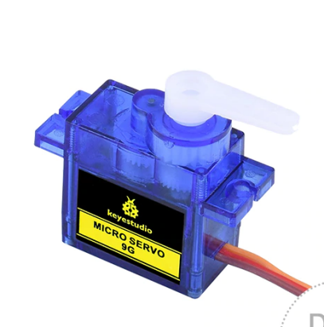

The servo is a kind of position servo driver, which is mainly composed of a housing, a circuit board, a coreless motor as well as a gear and position detector. The working principle is that the receiver or microcontroller sends a signal to the servo, which has an internal reference circuit that generates a reference signal with a period of 20ms and a width of 1.5ms, and compares the DC bias voltage with the voltage of the potentiometer to output voltage difference. The IC on the circuit board determines the direction of rotation, and then drives the coreless motor to start rotation and transmits the power to the swing arm through the reduction gear, while the position detector sends back a signal to determine whether it has reached the positioning. It is suitable for those control systems that require constant change of angle and can be maintained. When the motor rotates at a certain speed, the potentiometer is driven by the cascade reduction gear to rotate so that the voltage difference is 0 and the motor stops rotating. The angle range of general servo rotation is 0 to 180 degrees.

The pulse period for controlling the servo is 20ms, the pulse width is 0.5ms to 2.5ms, and the corresponding position is -90° to +90°. The following is an example of a 180 degree servo.

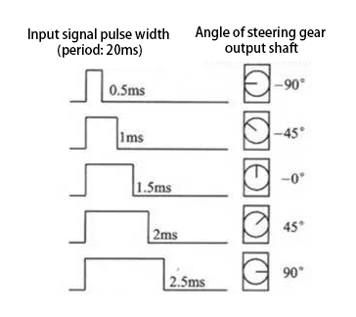

Servo motors have many specifications, but they all have three connecting wires, which are brown, red, and orange (different brands may have different colors). The brown is GND, the red is the positive power supply, and the orange is the signal line.

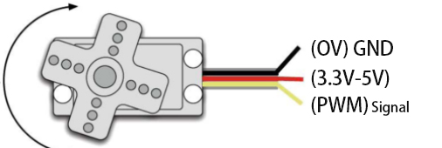

1. **Wiring Diagram**

When supplying the servo, please note that the power supply voltage should be 3.3V-5V. Make sure there are no errors when connecting the servo to the power supply.

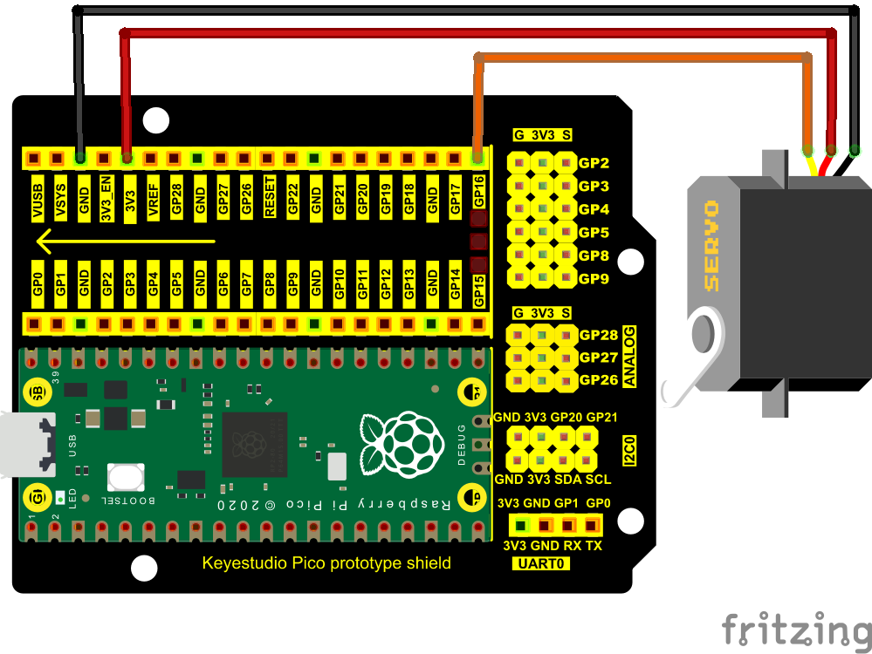

**5.Test Code**

The code used in this project is saved in the file KS3020 Keyestudio Raspberry Pi Pico Learning Kit Ultimate Edition\2. Windows System\1. Python\_Tutorial\2. Python Projects\Project 19：Servo Sweep. You can move the code to anywhere, for example, we can save the code in the Disk(D), the route is D:\2. Python Projects.

Open“Thonny”, click“This computer”→“D:”→“2. Python Projects”→“Project 19：Servo Sweep”. Select“myservo.py”，right-click and select“Upload to /”, waiting for the“myservo.py”to be uploaded to the Raspberry Pi Pico. And double left-click the“Project\_19\_Servo\_Sweep.py”.

**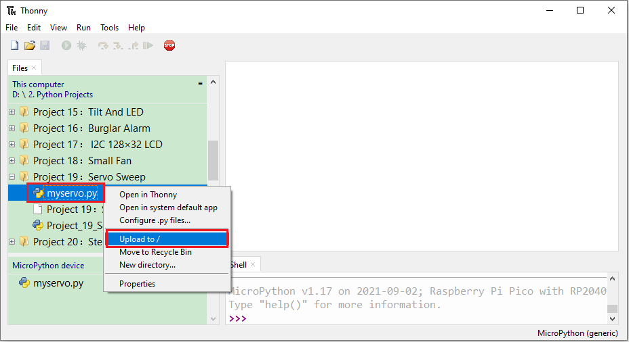**

**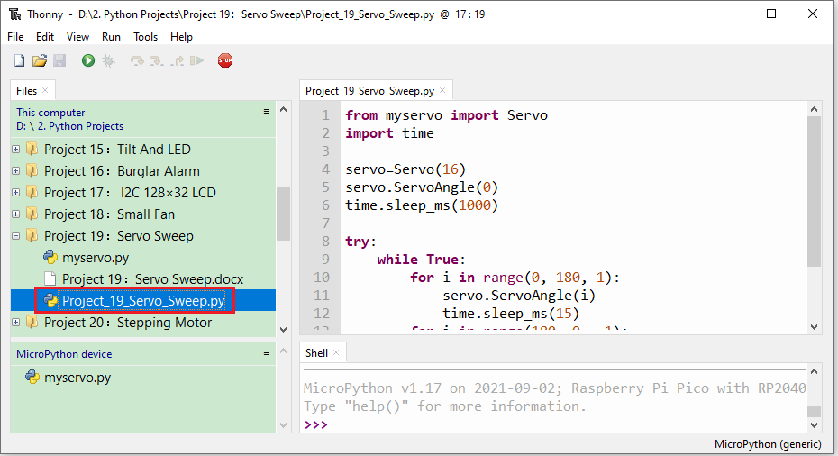**

|  |
| --- |
| from myservo import Servo  import time  servo=Servo(16)  servo.ServoAngle(0)  time.sleep\_ms(1000)  try:  while True:  for i in range(0, 180, 1):  servo.ServoAngle(i)  time.sleep\_ms(15)  for i in range(180, 0, -1):  servo.ServoAngle(i)  time.sleep\_ms(15)  except:  servo.deinit() |

1. **Test Result**

Ensure that the Raspberry Pi Pico is connected to the computer，click“Stop/Restart backend”.

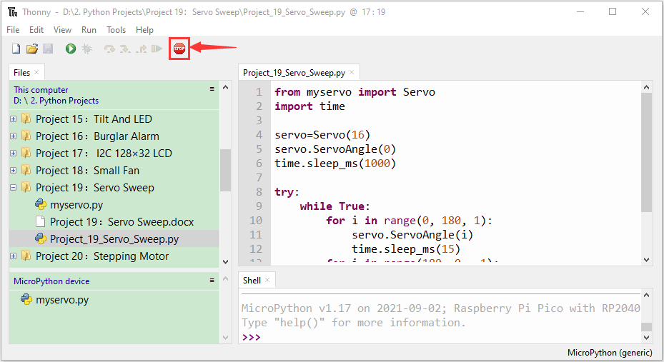

Click “Run current script”, the code starts executing, we will see that the servo will rotate from 0° to 180°, then reverse direction to rotate from 180° to 0°, and repeat these actions in an infinite loop. Press“Ctrl+C”or click“Stop/Restart backend”to exit the program.

